ASSIGNMENT 3

**Q1-**

Taking (x,y). 0≤x≤4 and 0≤y≤3.

Fill 4 gallon jug > Pour 3 gallon of water from 4 to 3 gallon > Pour 3 gallon jug water onto the ground and pour water from 4 gallon jug into 3 gallon jug > Fill the 4 gallon jug > Pour water from 4 gallon jug to 3 gallon jug > Pour the water of 3 gallon jug onto ground > 2 gallons of water left in 4 gallon jug. GOAL STATE.

6 nodes expanded.

**Q2-**

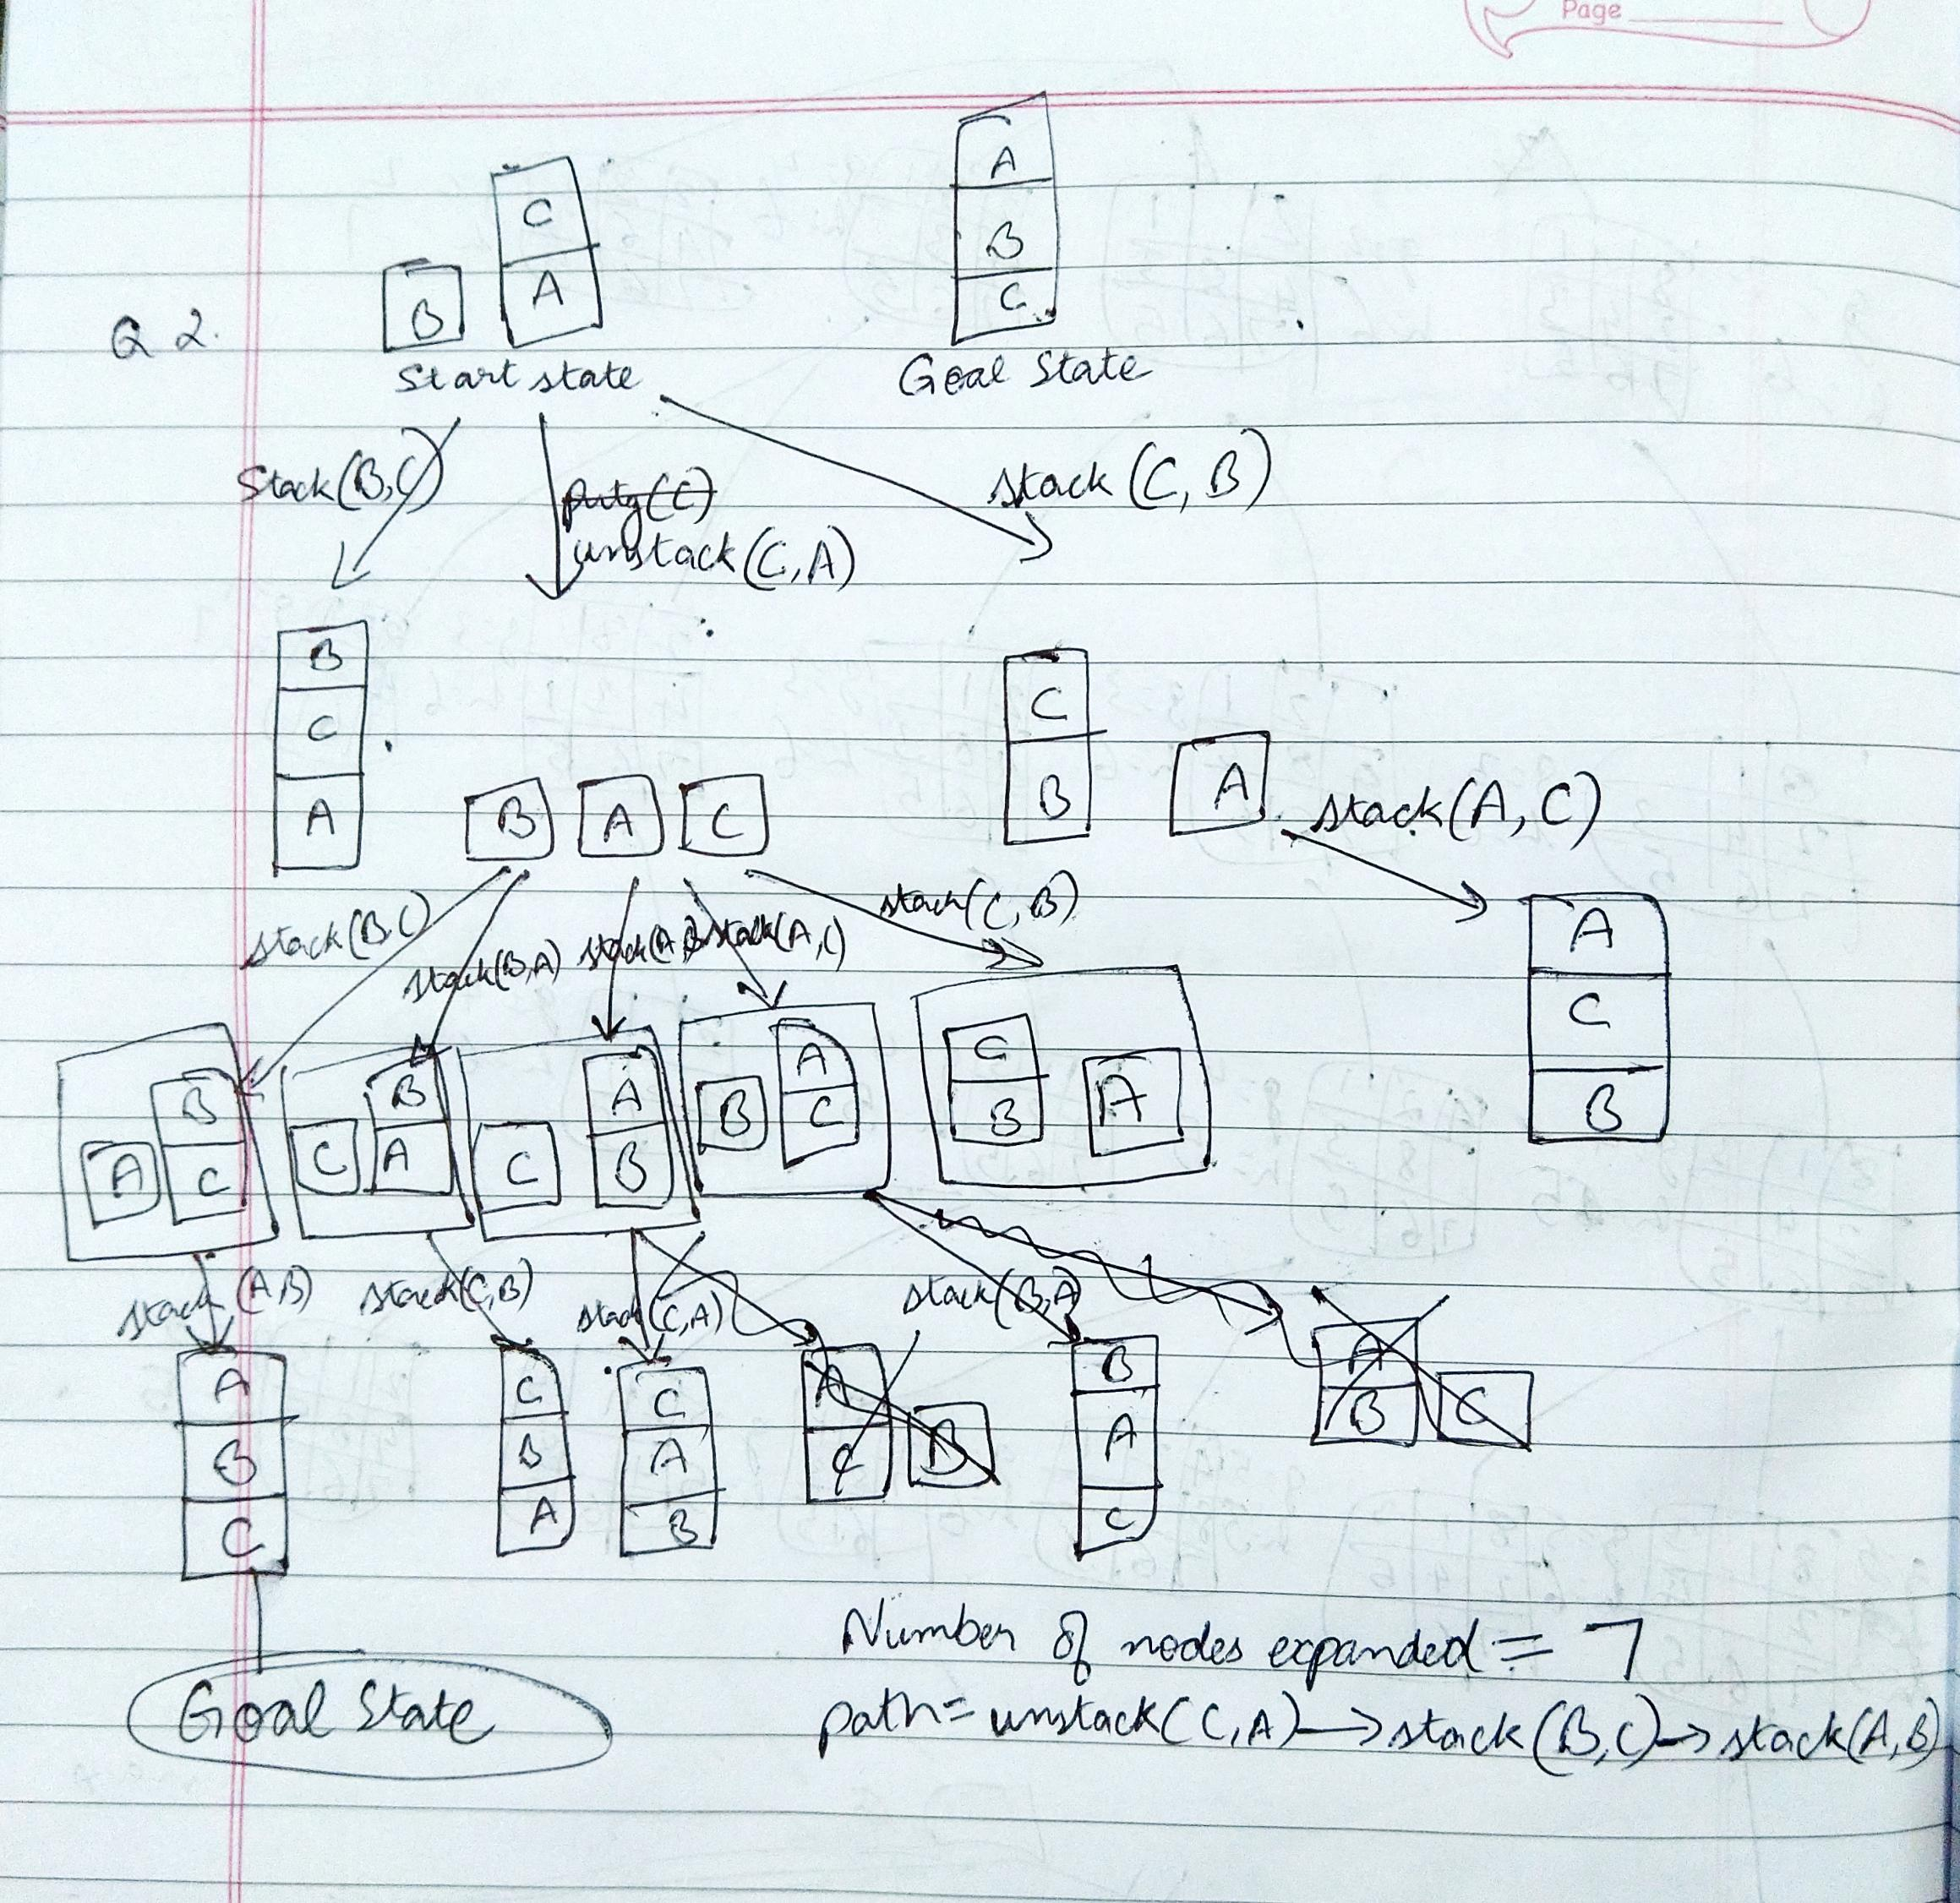

**Q3-**

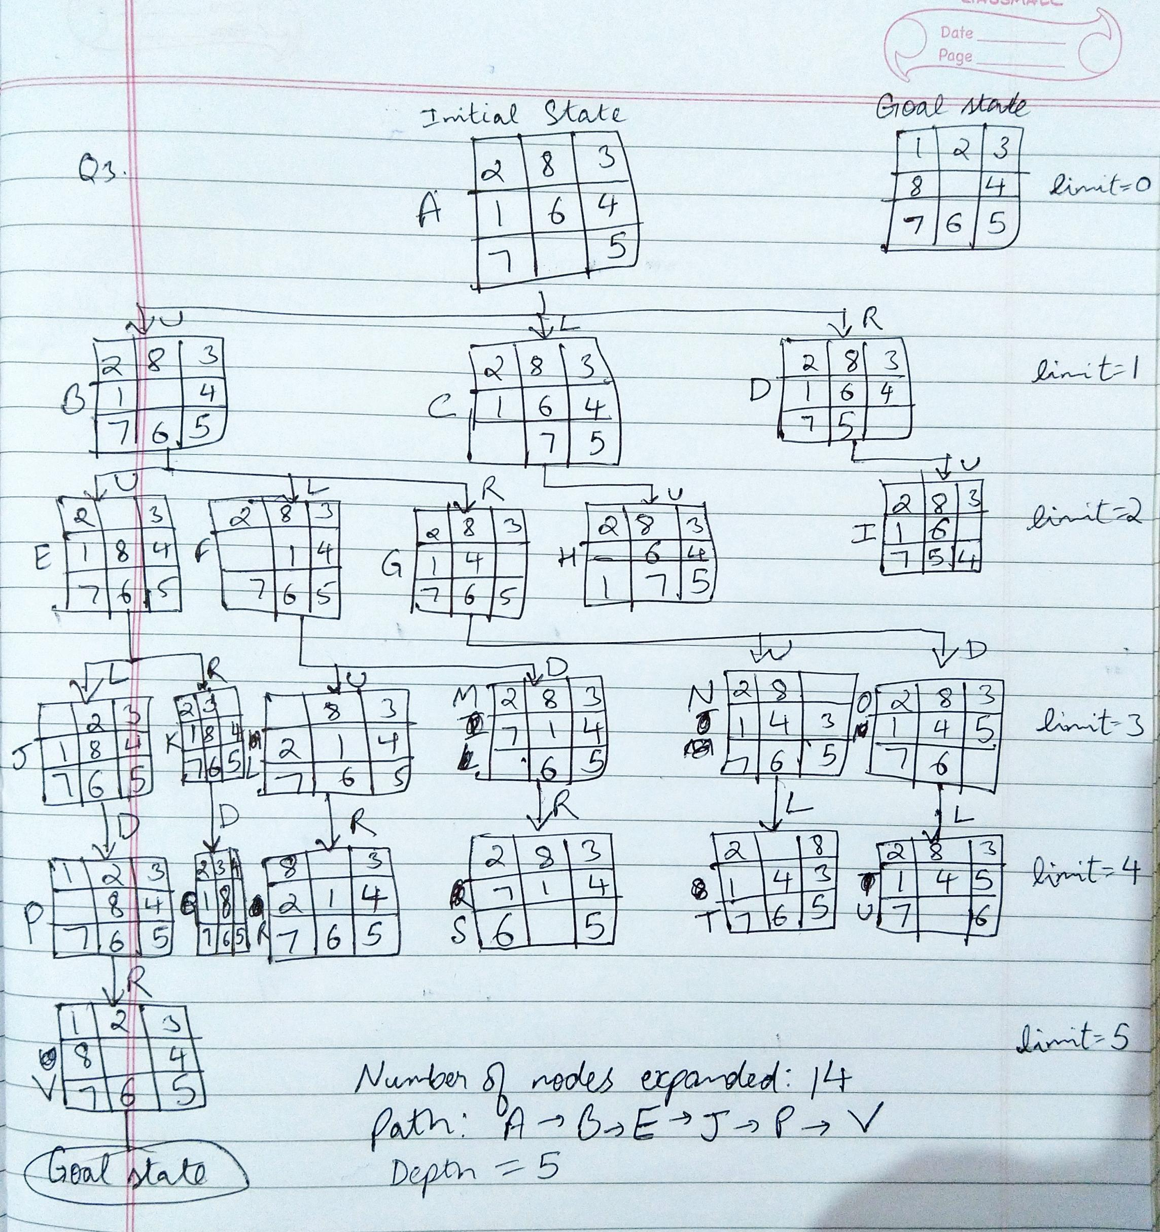

**Q4-**

Number of nodes expanded: 12

Path: [3,3,1] > [3,1,0] > [3,2,1] > [3,0,0] > [3,1,1] > [1,1,0] > [2,2,1] > [0,2,0] > [0,3,1] > [0,1,0] > [0,2,1] > [0,0,0]

**Q5-**

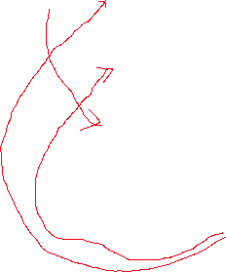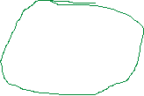

Number of nodes expanded: 9

Optimal path: Arad > Sibiu > Rimnicu Vileea > Pitesti > Bucharest

(The path Sibiu > Fagaras > Bucharest has less steps but is longer distance.)